YAMNA AFTAB
DECODESLAB INTERNSHIP
PROJECT #1

CHATBOT – Rule-Based AI Chatbot Using C++
Abstract:
CHATBOT is a simple Rule-Based Artificial Intelligence application developed in C++. The chatbot communicates with users through text-based conversation. It uses the C++ "unordered_map" data structure to store predefined questions and responses. When a user enters a message, the chatbot searches for a matching response and displays it. If no matching response is found, it returns a default reply. This project demonstrates the basic concept of Artificial Intelligence and human-computer interaction.
Introduction:
Artificial Intelligence (AI) is a branch of computer science that enables machines toperform tasks that normally require human intelligence. One of the most common applications of AI is a chatbot
A chatbot is a software application that interacts with users through text or voice communication. Chatbots are widely used in customer support, education, healthcare, and business applications
This project presents a simple rule-based chatbot developed in C++. The chatbot uses predefined responses stored in an "unordered_map" and responds according to user input
Objectives:
To understand the basic concepts of Artificial Intelligence.
To develop a simple chatbot using C++.
To learn the implementation of "unordered_map".
To create an interactive command-line application.
To understand rule-based conversation systems.
-To improve programming and problem-solving skills .
Scope of the Project:

The chatbot can:

Respond to predefined user queries.
Interact through a text-based interface.
Provide instant responses.
Handle simple conversations.
Demonstrate the basic working of Artificial Intelligence.
Hardware Requirements:
- Intel Core i3 Processor or above
- 4 GB RAM
- 100 MB Free Disk Space

Software Requirements:

- Visual Studio Code
- C++ Compiler (MinGW/G++)
- Windows 10/11
- Standard C++ Library

Methodology:
The chatbot follows a rule-based approach.

Step 1

Store predefined questions and answers in an "unordered_map".

Step 2

Take input from the user.

Step 3

Convert the input into lowercase format.

Step 4

Search for the input in the chatbot database.

Step 5

If a matching response exists, display it.

Step 6

If no matching response exists, display a default response.

Step 7

Continue until the user enters "exit".
System Flowchart:

Start

↓

Store Responses in unordered_map

↓

Take User Input

↓

Convert Input to Lowercase

↓

Is Input = Exit?

Yes → End Program

No

↓

Response Found?

Yes → Display Response

No → Display Default Response

↓

Repeat
Data Structure Used:
unordered_map
The chatbot uses the C++ STL container "unordered_map".

Advantages of unordered_map:
Fast Searching
Fast Insertion
Key-Value Storage

Source Code:
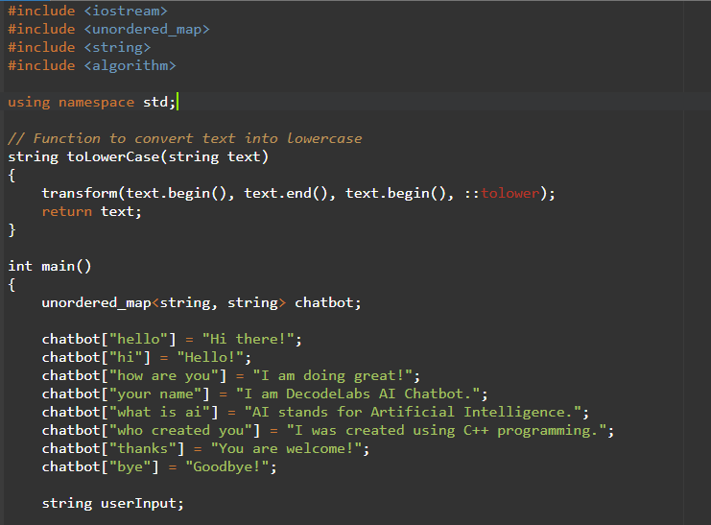
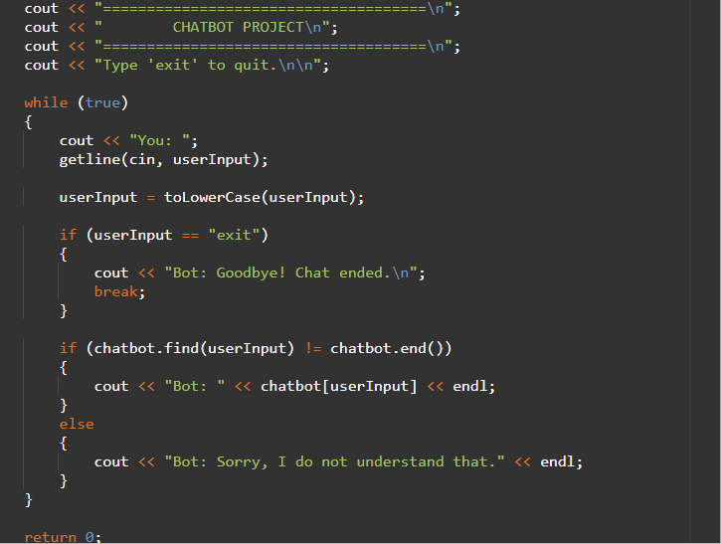

Output:
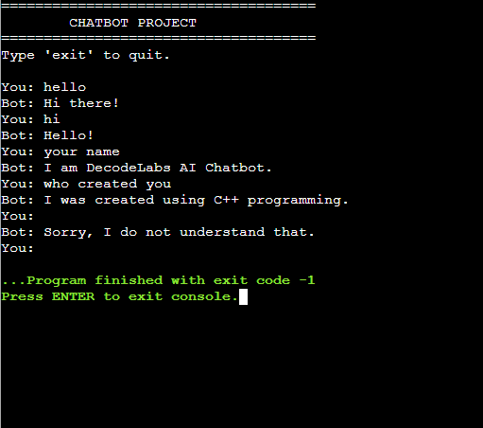

Conclusion:

The CHATBOT project successfully demonstrates the implementation of a simple rule-based conversational AI system using C++. The project utilizes the "unordered_map" data structure to efficiently store and retrieve predefined responses. This project provides a strong foundation for understanding chatbot development and Artificial Intelligence concepts. It is simple, efficient, and suitable for beginners who want to learn AI fundamentals using C++
References:

1. C++ Programming Language Documentation
2. Standard Template Library (STL) Documentation
3. Artificial Intelligence Fundamentals
4. Visual Studio Code Documentation
5. C++ Reference Library

